T.E. COMPS - A

|  |  |
| --- | --- |
| **Name** | Shubham Golwal |
| **UID no.** | 2021300015 |
| **Experiment No.** | 01 |
|  | **Assignment 1** | |
| **AIM:** | Design webpages using HTML, CSS, and JavaScript. | |
| **THEORY:** | **HTML:**  HTML (HyperText Markup Language) is the most basic building block of the Web. It defines the meaning and structure of web content. Other technologies besides HTML are generally used to describe a web page's appearance/presentation (CSS) or functionality/behavior (JavaScript).  "Hypertext" refers to links that connect web pages to one another, either within a single website or between websites. Links are a fundamental aspect of the Web. By uploading content to the Internet and linking it to pages created by other people, you become an active participant in the World Wide Web.  HTML uses "markup" to annotate text, images, and other content for display in a Web browser. HTML markup includes special "elements" such as <head>, <title>, <body>, <header>, <footer>, <article>, <section>, <p>, <div>, <span>, <i mg>, <aside>, <audio>, <canvas>, <datalist>, <details>, <embed>, <nav>, <output>, <progre ss>, <video>, <ul>, <ol>, <li> and many others.  An HTML element is set off from other text in a document by "tags", which consist of the element name surrounded by "<" and ">". The name of an element inside a tag is case insensitive. That is, it can be written in uppercase, lowercase, or a mixture. For example, the <title> tag can be written as <Title>, <TITLE>, or in any other way.  **CSS:**  Cascading Style Sheets (CSS) is a stylesheet language used to describe the presentation of a document written in HTML or XML (including XML dialects such as SVG, MathML or XHTML). CSS describes how elements should be rendered on screen, on paper, in speech, or on other media.  CSS is among the core languages of the open web and is standardized across Web browsers according to W3C specifications. Previously, the development of various parts of CSS specification was done synchronously, which allowed versioning of the latest recommendations. You might have | |

|  |  |
| --- | --- |
|  | heard about CSS1, CSS2.1, CSS3. However, CSS4 has never become an official version.  From CSS3, the scope of the specification increased significantly and the progress on different CSS modules started to differ so much, that it became more effective to develop and release recommendations separately per module. Instead of versioning the CSS specification, W3C now periodically takes a snapshot of the latest stable state of the CSS specification.  **JavaScript:**  JavaScript (JS) is a lightweight, interpreted, or just-in-time compiled programming language with first-class functions. While it is most well-known as the scripting language for Web pages, many non-browser environments also use it, such as Node.js, Apache CouchDB and Adobe Acrobat. JavaScript is a prototype-based, multi-paradigm, singlethreaded, dynamic language, supporting object-oriented, imperative, and declarative (e.g. functional programming) styles. Read more about JavaScript.  This section is dedicated to the JavaScript language, not the parts specific to Web pages or other host environments. For information about API specifics to Web pages, please see Web APIs and DOM.  The standards for JavaScript are the ECMAScript Language Specification (ECMA-262) and the ECMAScript Internationalization API specification (ECMA-402). The JavaScript documentation throughout MDN is based on the latest draft versions of ECMA-262 and ECMA-402. And in cases where some proposals for new ECMAScript features have already been implemented in browsers, documentation and examples in MDN articles may use some of those new features.  Do not confuse JavaScript with the Java programming language. Both "Java" and "JavaScript" are trademarks or registered trademarks of Oracle in the U.S. and other countries. However, the two programming languages have very different syntax, semantics, and use. |
| **Problem Statement: Creating a website for an NGO using HTML, CSS, and JavaScript.** | |
| **TECH STACK:** | * HTML for **structuring** * CSS for **styling** * JavaScript for **functionality** |
| **REQUIREMENTS:** | VS Code (Text Editor), Browser |
| **IMPLEMENTATION:**  Created a classic Cars website with a sidebar on the left side, having multiple pages and functionalities and also contact. | |

**Homepage:**

**Popular cars page:**

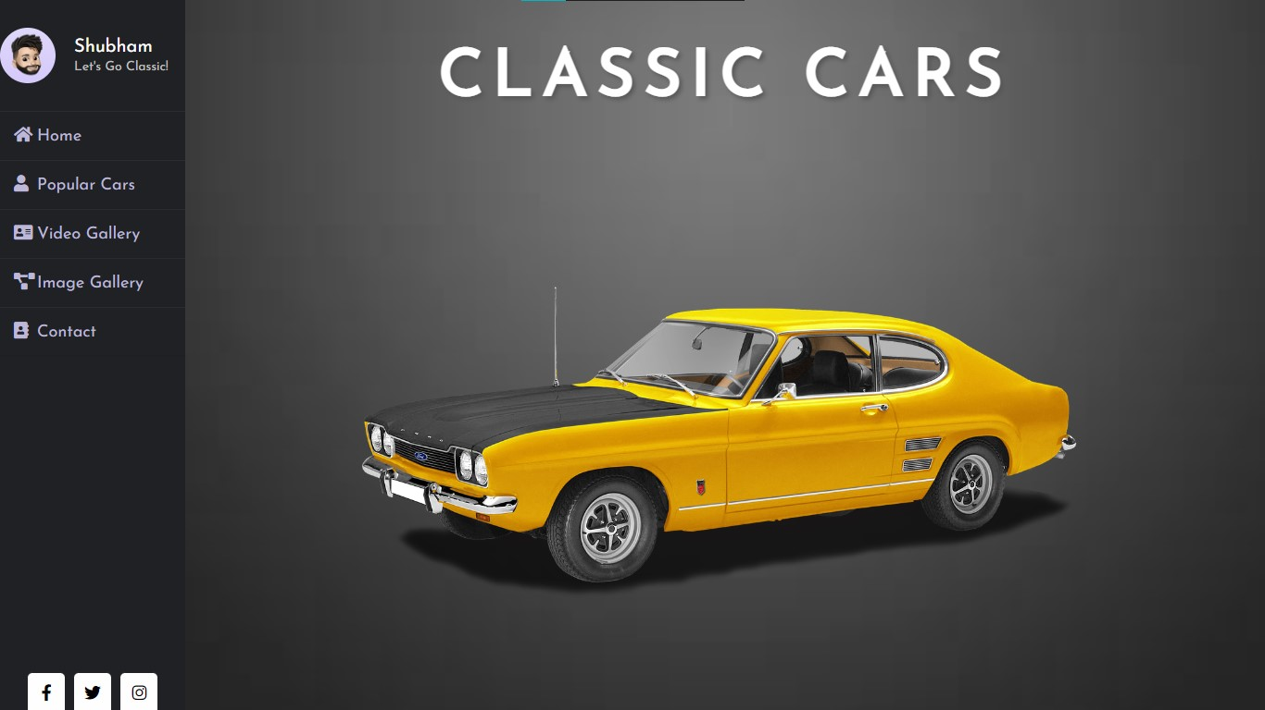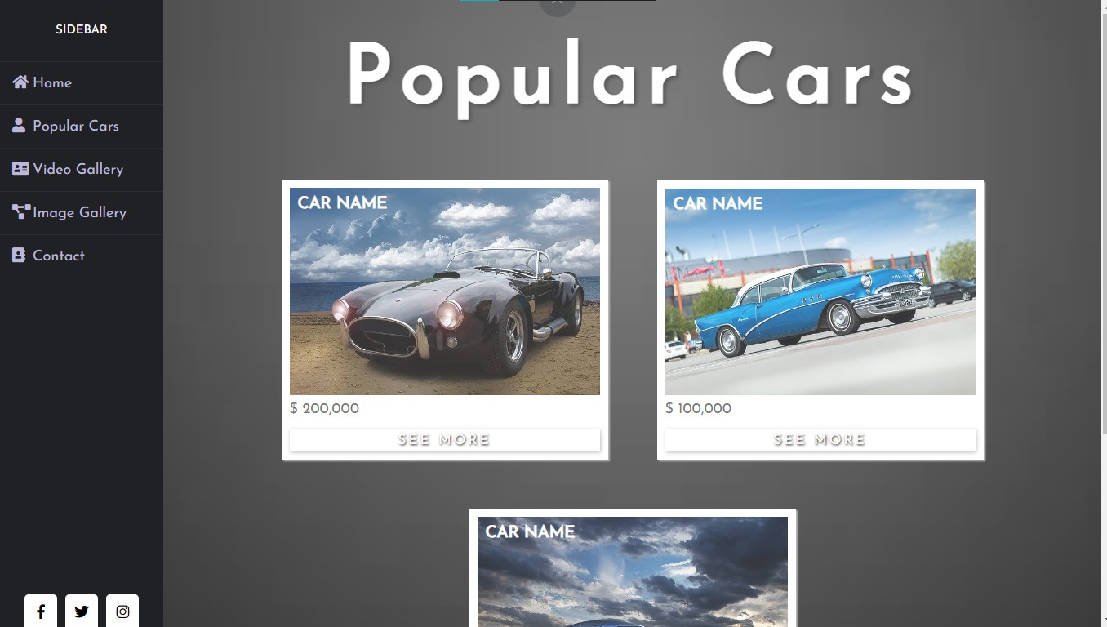

**Video gallery page:**

**Image gallery page:**

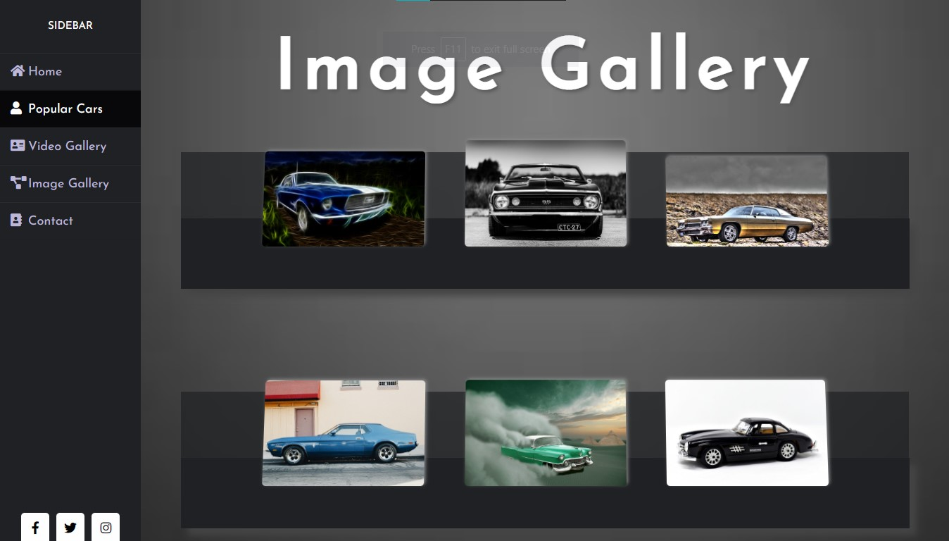

|  |  |
| --- | --- |
| **Contacts page:** | |
| **CONCLUSION:** | Through this experiment, I learned how to create a responsive website using HTML, CSS, and JavaScript. HTML is used to form the basic structure of your website and is like a skeleton. CSS adds beauty to the HTML code and makes your website more aesthetic and appealing to the eye hence it is used to style the website. JavaScript is used to make the website responsive and actually add functionality to the website. |
| **REFERENCES:** | * <https://www.w3schools.com/html/><https://www.w3schools.com/css/> * <https://www.w3schools.com/js/> * <https://developer.mozilla.org/en-US/> * The Complete Web Development Bootcamp by Angela   Yu:[https://www.udemy.com/course/the-complete-web-developme nt](https://www.udemy.com/course/the-complete-web-development) Bootcamp/learn/lecture/12383818?start=75#overview |